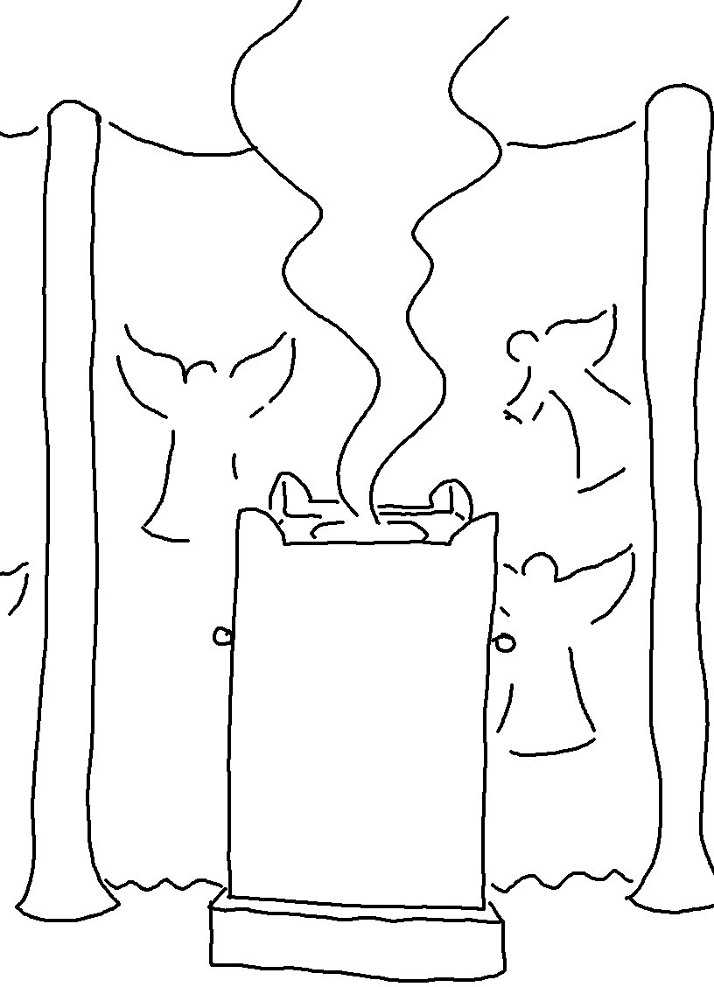
"Let us go to the house of the Lord." Psalms 122:1_{NLT}

